Physics 3A/3B

Motion and Forces in a Gravitational Field

Test 2

Circular and Gravitational Motion
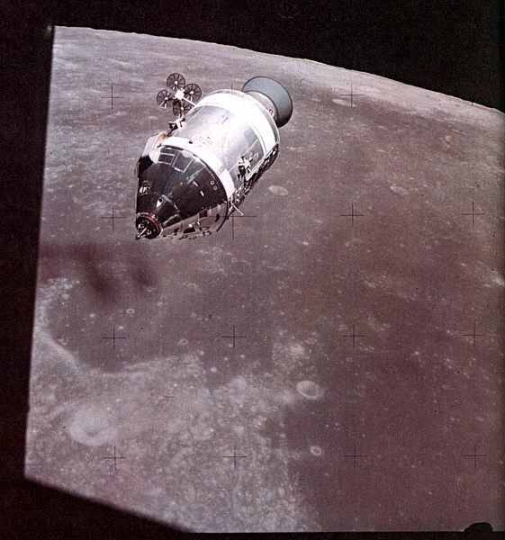

Time allowed: 60 min
Answer all questions on the paper provided
To achieve full marks, clear, logical
working and diagrams MUST be shown.
Answers should be evaluated with an
appropriate number of significant figures.

Section A: 7 Short Answer: 22 marks

1 Astronauts in training for weightlessness are given some practice in a plane, which flies in vertical loop of radius 600 m at such a speed that at the top of the path they feel “weightless”. At what speed must the plane be flying to achieve this effect? r = 600m v = √gr

= √ 9.8 x 600

= 76.7 ms⁻¹
(3marks )

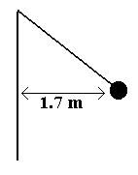2. A hammer thrower has gradually increased the speed of his hammer so that it completes ten revolution in 22.0 s. The hammer of mass 7.26 kg may be considered to be moving in a horizontal circle of 1.70 m radius. What force is exerted through the cable on the hammer thrower’s arm?
(4 marks)

10 rev = 22 s  1 rev = 2.2 s  T = 2.2 s  r = 1.70 m  m = 7.26 kg  F_{w} = mg  = 7.26 x 9.8  = 71.148 N  [1 mark] | 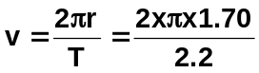  v = 4.8552 ms⁻¹ [1 mark]  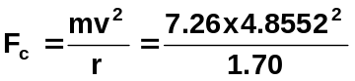  F_{c} = 100.67 N [1 mark]  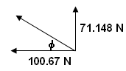  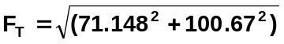  F_{T} = 123.27 N  φ = tan⁻¹ (71.148 ÷ 100.67)  φ = 35.3⁰  F_{T} = 123 N 35.3⁰ above horizontal  [1 mark]
3.. A railway line goes around a curve of radius 5.00 x 10³ m. It is designed to carry a train travelling at 1.00 x 10² ms⁻¹. What would be the angle of banking for the tracks which would result in the best cornering?
(3 marks)

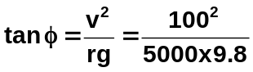
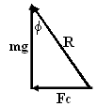
tan φ = Fc = mv²/r [2 mark]
mg mg
tan φ = v²
rg tan φ = 0.2041
φ = 11.5⁰ [1 mark]

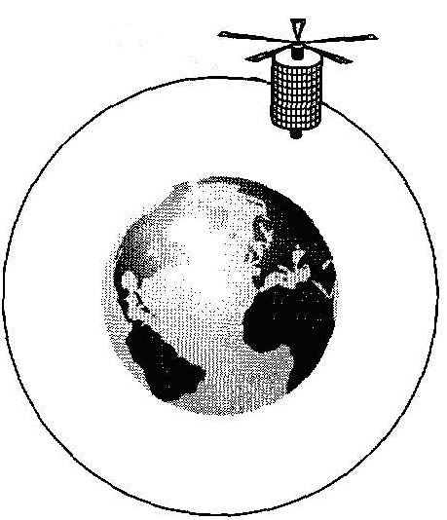
- A satellite is in a circular orbit around the Earth. Draw a diagram which would indicate both the instantaneous velocity and the net force acting on the satellite?
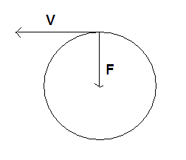

(2 marks)

5. The MT SAT-1R is a geostationary satellite. Briefly describe two features of the motion of such a satellite and describe a possible function based on these features. - period = 24Hr (1)
- Equitorial Orbit (1)
- Stationary relative to fixed point on surface (1)
- fixed radius (1)
ANY TWO OR ACCEPTABLE ALTERNATIVE Use – Communication , weather ( 1 ) (3 marks)

6. If the acceleration due to gravity on the Earth’s surface is “g.” What would be the new value of the acceleration due to gravity if the Earth’s radius was reduced to a quarter of it’s present value?
(2 marks)
g₁ = Gm g₂ = Gm
r² (r/4)²

= 4² Gm
r²
= 16 g = 156ms⁻²

7. Calculate the gravitational field strength acting on the NAVSTAR GPS Satellite orbiting at an altitude of 6.00 x 10² km above the surface of the earth.
r = re + 6.0 x 10⁵ m g₁ = Gm
= 6.97 x 10⁶ m (1) r²
= 6.67 x 10⁻¹¹ 5.97 x 10²⁴
(6.98 x 10⁶)²

= 8.17 NKg⁻¹ (2)

(3 marks)
Section B: 4 Extended answer questions: 23 marks

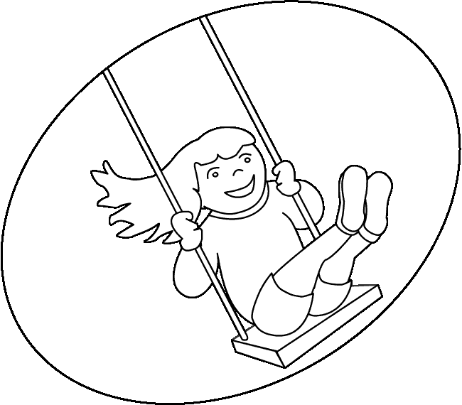
- Sharon is playing on a swing which is supported by two cables of length 2.60m. She is able to swing her mass, of 37 kg, and the swing seat, 2.40 kg, to a height of 0.850 m (point P and R ) above
the lowest point of the swing ( point Q ).
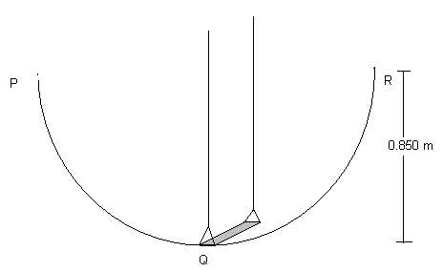

- At which point in the swing will Sharon have the greatest velocity
and what is that velocity?
Point Q 1 mark

PE_{R} = KE_{Q}
mgΔh = ½ mv²
2 x 9.8 x .85 = v²
V = 4.08 ms⁻¹ 2 marks
(3 marks )
- The tension in the cables will vary as the swing moves through its arc. What will be the maximum tension in each cable?
F_{n} = T + w
T
W
mv²↑ = T + mg ↓
r

T = mv²↑ -- mg ↓
r

= mv²↑ + mg ↑ 1 mark
r

= 39.4 x(4.08)² + 39.4 x 9.8
2.6

= 252 .26 + 386.12

= 638.4 N 2 marks

Per cable 319 N 1 mark
(4 marks )
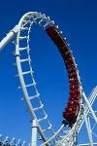
- A roller-coaster has a vertical loop of radius 40.0 m. The coaster runs inside the loop so that the passengers are upside down. The owners of the roller-coaster advertise that the passengers will never fall out even if they are not belted in.

a) Are the owners correct? Using physics principles explain your answer.
No 1 mark

R F_{n}↓ = R↓ + w↓

R↓ = F_{n}↓ -- w↓
W
= F_{n}↓ + w↑

F_{n} → w → R → 0

V² must be greater than g or r passengers will fall
2 marks
(3 marks)

b) Calculate the minimum speed required to keep the passengers in the coaster? r = 40 m v = √gr

= √ 9.8 x 40

= 19.8 ms⁻¹ 3 marks

(3 marks)
3. The Hubble Space Telescope (of mass 1.16 x 10⁴ kg) orbits the earth in a circular orbit 6.10 x 10² km above the earth’s surface.

a) Calculate the gravitational force of attraction between the Earth and the telescope?

r= 6.10 x 10⁵ + 6.38 x 10⁶
= 6.99 x 10⁶ m (1)

F = Gmm
r² = 6.67 x 10⁻¹¹ x 1.16 x 10⁴ x 5.97 x 10²⁴
(6.99 x 10⁶)²
= 9.45 x 10⁴ N (2)
(3 marks )
b) Calculate the period of the Space Telescope? F=mv² v=2πr
r T

T = √m4π² (2)
F
= √1.16 x 10⁴ x 4 π² x 6.99 x 10⁶
9.45 x 10⁴
= 5.82 x 10³ s (2)

OR T² = 4π²r³
Gm
(4 marks )

4, Given that the period of orbit of the earth’s moon is 27.3 days, determine the period of the new international space station, which has a mass of 7.5 tonne, given that its orbit is 1/10 of the earth – moon radius?
T_{m} = 27.3 days
r_{m} = 3.84 x 10⁸ m

r_{s} = 1/10 x 3.84 x 10⁸
= 3.84 x 10⁷ m (1)

r_{m}³ = r_{s}³
T_{m}² T_{s}²

T_{s}² = (3.84 X 10⁷)³ x (27.3)² (2)
(3.84 x 10⁸)³

T = 0.863 days (1)
(4 marks )

The Long Method gives a slightly different answer:

Fc = Fg

mv² / r = GMm/r²

v² = GM/r

find v then

use v = 2πr/T to calculate T (or by sub back into the bigger equation at start)

T = 7.49x10⁴ s

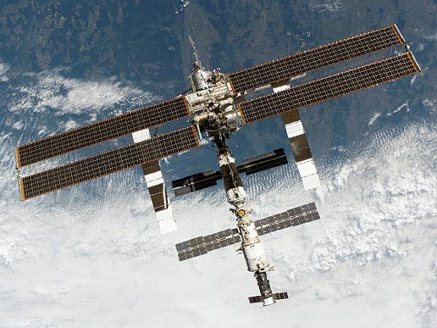
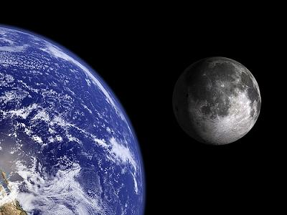

End of Test

